Colors: Blue, green , yellow

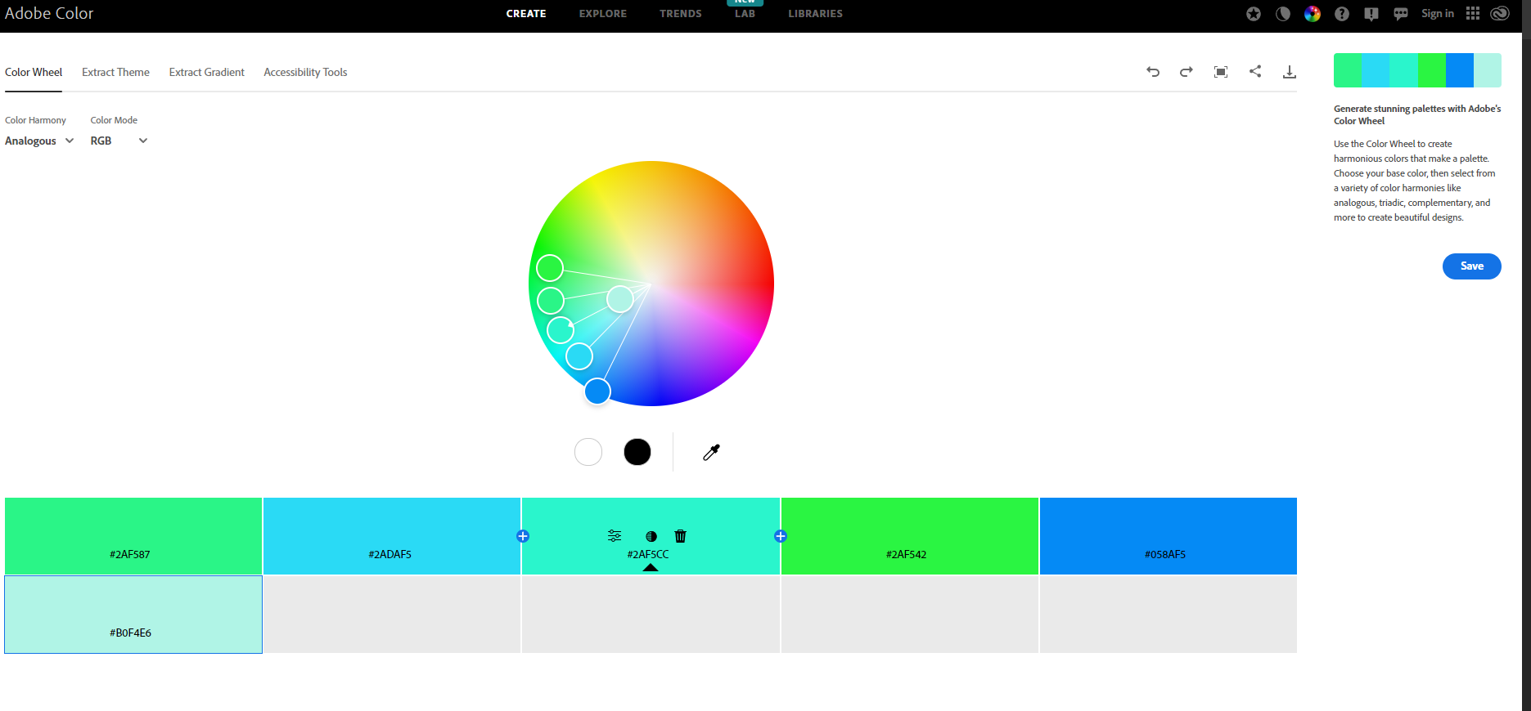

Shades of blue and green will be main

Accents of yellow

